AutoLISP program by Terry Miller Block Library Email: terrycadd@yahoo.com

Block Library is an AutoLISP utility for managing blocks by storing blocks and block slide images in Block Libraries. The block slide images can be quickly viewed in the Block Libraries before inserting them into a drawing.

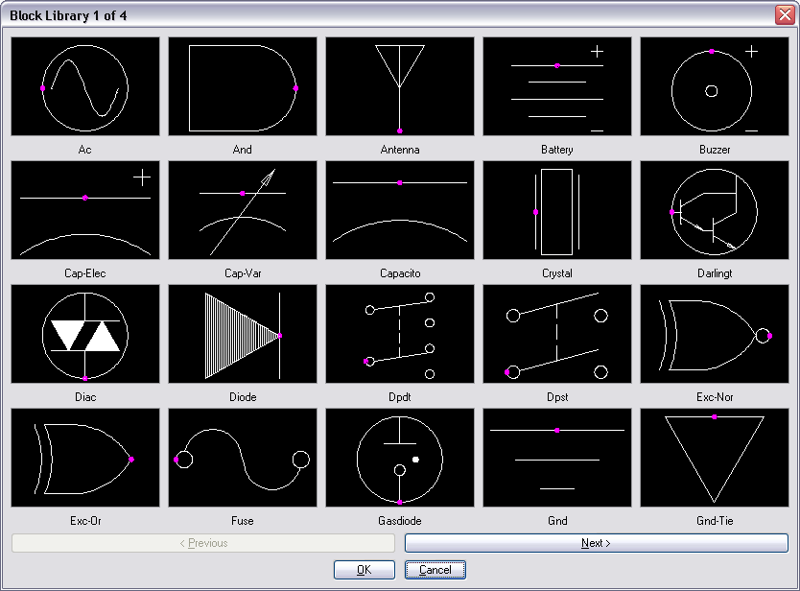

The blocks and slides are added through the Block Library Manager, which allows you to view and select the blocks you want to add. The Block Library Manager also allows you to control the insertion point, layer and scale of a block when it is inserted. The toggle for “Explode” inserts the block exploded. The toggle for “Insertion Dot” includes a Dot in the slide for a visual reference insertion point.

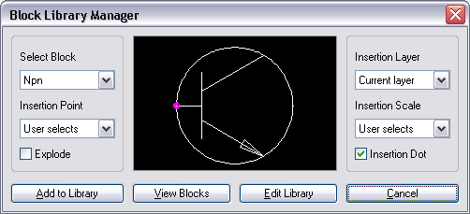

To select a block to add, select a block from the “Select Block” list or select “View Blocks” to view all of the blocks and select the block you want to add. The default options of “User selects” for insertion point and scale will insert the block with the standard AutoCAD insert block method. If you select other options from either of these lists, you control the insertion point or scale of the block added. This is useful for blocks that are always inserted in reference to a title block. If you select the “Manager selects” option for “Insertion Point” or “Insertion Scale” you will be prompted for the insertion point or scale after you select “Add to Library”.

Edit Block Library allows you to rearrange or delete the reference to blocks in the Block Libraries. The blocks and slides are not deleted, only the reference to them is omitted in the Block Library definition files. Block slide images may be rearranged easily by using the “Move” and “Paste” buttons.

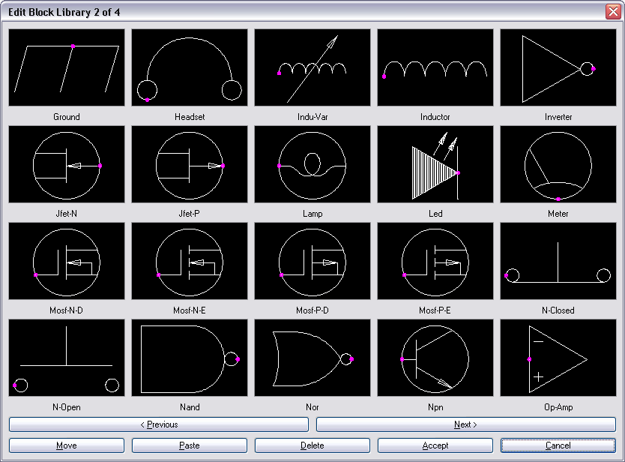

Select Block Library allows you to add, edit, or select a Block Library. It lets you customize the Block Library titles and path locations for storing slides and blocks.

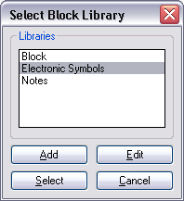

Edit Library Definitions allows you to change a Block Library title and path locations for storing blocks and slides. You may also delete a reference to a title for the Select Block Library.

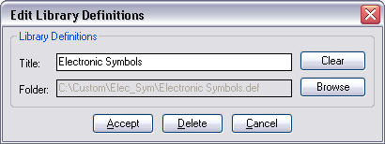

Add Library Definitions allows you to add a new Block Library title for storing a new category group of blocks and slides.

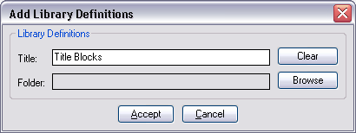

The “Browse” buttons in the Add and Edit Library Definitions use the AutoCAD getfiled dialog function for creating new folders to save the definition file. Click “Browse” to locate the folder to use by selecting the “Save in:” dropdown list or the “Up One Level” icon. Then click on the “Create New Folder” icon and type in the new folder name. Double click on the “Folder” icon for the new folder name to make it current in the “Save in:” folder display. Verify that the “Save in:” folder and the “File name:” edit box are correct before selecting the “Open” button to accept.

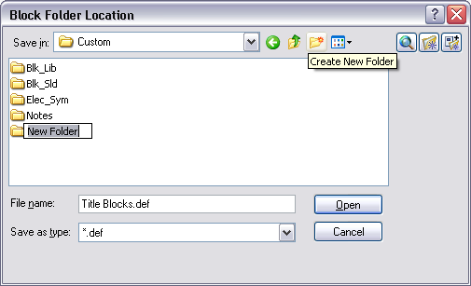

Insert Blocks uses the AutoCAD getfiled dialog function to browse and select a folder containing drawing blocks that you want to insert and add to the Block Library. These blocks may be added individually to libraries through the Select Block Library and then selecting the Block Library Manager to add a block. Insert Blocks may be used with All Blocks to Library to quickly add all the blocks in drawing to a Library.

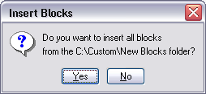

All Blocks to Library allows you to select the Library you want to add all the blocks in drawing to. This method for adding blocks uses the defaults of the Block Library Manager with the standard AutoCAD insert block method. Blocks are added alphabetically and may be modified through the Edit Block Library to rearrange or delete the reference to blocks in the Block Libraries.

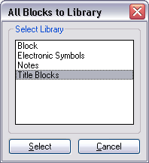

Drawing Blocks allows you to view and insert the blocks in a drawing. The dialog for Drawing Blocks is similar to the dialog for Block Library with only an “OK” and “Cancel” button. This dialog is also used by “View Blocks”, within the Block Library Manager dialog, for selecting a block to display and use.

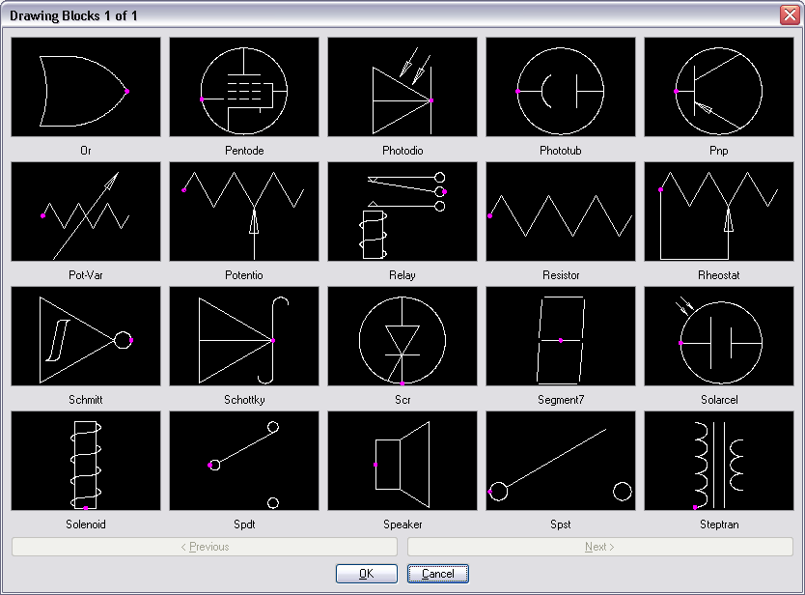

The Drawing Blocks dialog may also be used for Library applications; where as an AutoCAD Administrator controls the Network location of blocks and slides. The end user may only insert blocks, and not be able to modify blocks or change their Network locations.

Block Library saves a backup copy of your current drawing before it creates slides and wblocks as C:\Custom\Blk_Lib.dwg. If the program is interrupted or canceled for any reason, open the C:\Custom\Blk_Lib.dwg as a backup.

The Block Library Menu is a menu utility for selecting Block Library commands. It displays the Shortcuts and Commands, and also provides a Description of the Block Library command functions.

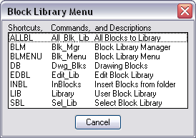

Block Library Instructions for New Installation

Block Library is managed by two files, Blk_Lib.lsp the AutoLISP file, and Blk_Lib.dcl the Dialog control file. Copy these files into a folder that is in your AutoCAD Support File Search Path where you save your AutoLISP functions.

Note: You can load Blk_Lib.lsp by adding (load "Blk_Lib.lsp") to your AcadDoc.lsp file, or use AppLoad to load Blk_Lib.lsp.

Block Library creates the folders C:\Custom, C:\Custom\Blk_Lib and C:\Custom\Blk_Sld as defaults to save temp slides and temp support files.

To execute the available Block Library commands type BLMENU on the command line to bring up the Block Library Menu. These commands may be added to your AutoCAD menu selection.

Block Library Program Information

Block Library is an AutoLISP program written by Terry Miller. Block Library is provided “as is”, that is without any expressed or implied warranty of any kind, nor liable for any losses or data resulting from the use of this program. Block Library has been tested successfully in AutoCAD 2008. Every effort has been made to make it a user friendly and bug free program. If you find Block Library to be beneficial for you as an AutoLISP utility, share it with your AutoCAD friends. If you have any suggestions or concerns for improvements to Block Library, please send an email to terrycadd@yahoo.com.

